**DESIGN DOC FOR Match-3 System**

* *This type of match-3 system is a clone of Candy Crush.*
* *The player will chose the level in the Menu Screen where:   
  Easy – The player can match any items amount >= 3.*

*Medium – The player can match only items amount = 4.*

*Hard – The player can match only items amount = 5.*

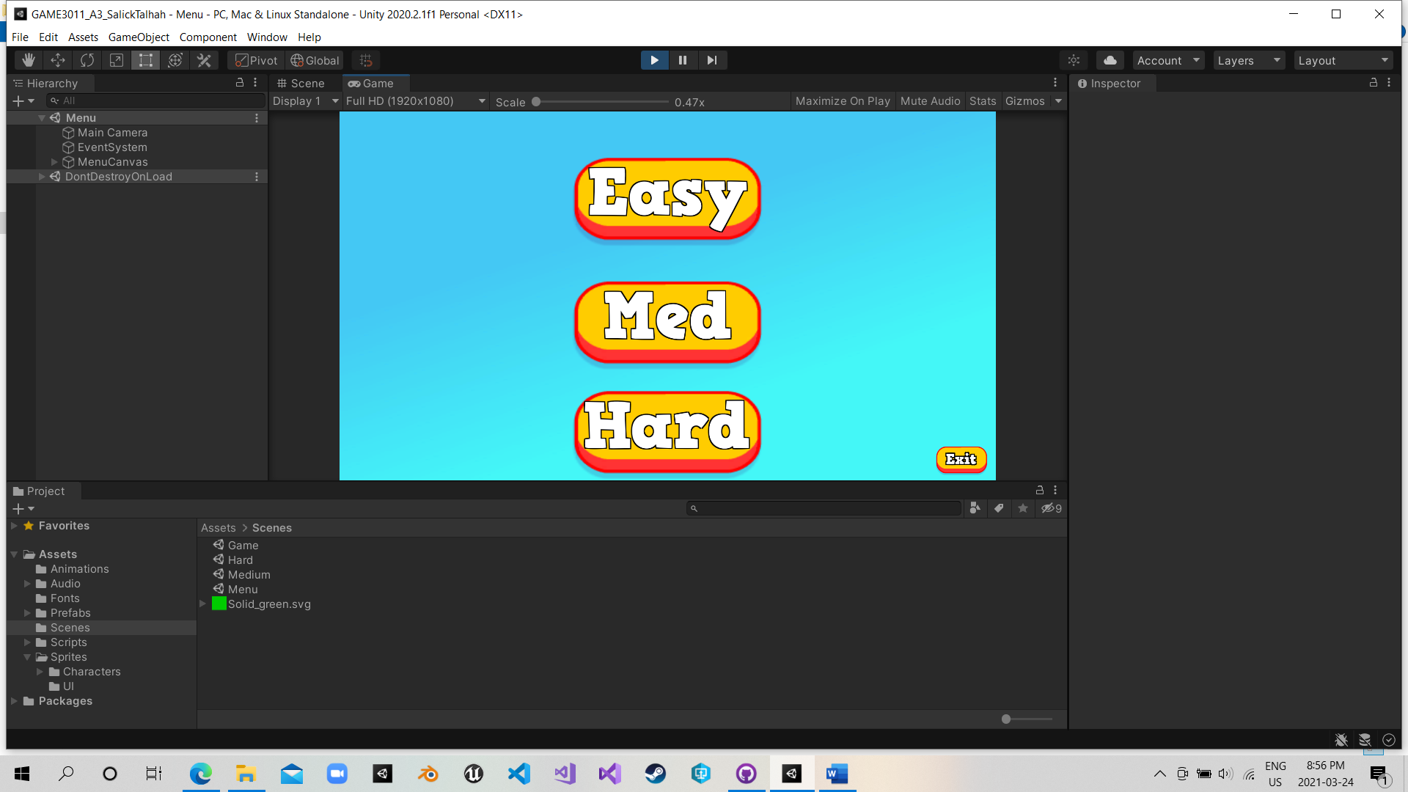

* *The player use the left click to select one item and click the other next to it to move to the clicked position.*

**UI**

* *In the buttom left, this is the move counter. Once it reach Zero, the game is over.*
* *The Bar on the right is the Timer, the player have 60 seconds to get the highest score.*
* *The score is in red anchored buttom right.*
* *The player can press Esc to leave the game.*

**Game over Screen.**

